**Target Image** 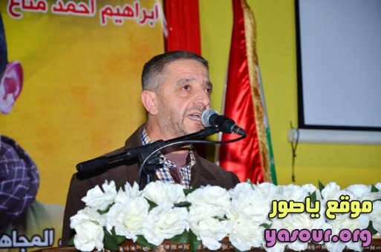

**Name:** Ahmed Fakih

**Age:** Unknown

**Pertinence:** Hezbollah Militias

**Occupation:** Burj El – Shemali

Tyre, Lebanon

**Marital Status:** Married

**Has Children:** Yes

**Home Address:**

1 – **Street:** Burj El – Shemali Main Street

**2 – Coordinates:** 33.263666, 35.236664

**3 – Satellite Image: (**The white arrow points to the target)

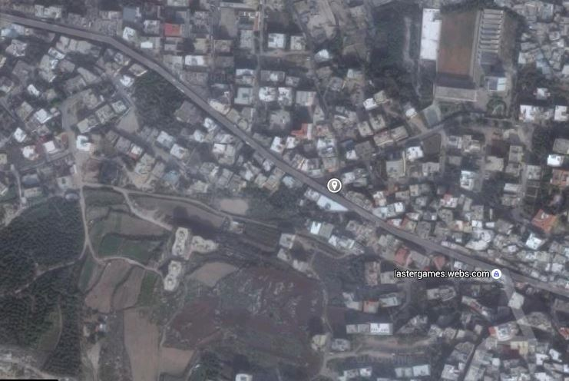

**Description:**

Ahmed Fakih, is a resident of Burj El – Shemali, a small town to the east of the city of Tyre in South Lebanon Governorate and an active member in the Lebanese Shiite militias of Hezbollah. He belongs to a very religious and extremist Shiite family (Fakih) which traces back its ethnicity into Persian Iranian Shiite origin. He is known as the presenter in all of Hezbollah’s festivals occurring in that town and one of the most active members of Hezbollah in it. He participates in all of Hezbollah’s meetings in the town, which involve the following subjects on table: When and who to choose from the town to send to Syria for fighting on the Syrian regime side – Hezbollah’s festivals in town – storing, buying and selling weapons – Hezbollah’s economic policies in the town – Training current Hezbollah’s militants and looking for new ones within the town – building new Hezbollah military and checkpoints points and maintaining/dismissing the old ones. In a future war between Israel and Hezbollah, he would certainly play an important role in transforming Burj El – Shemali into line of resistance against the Israeli Defense Forces and the Israeli Air Forces. His son, Habib Ahmed Fakih is one of Burj El – Shemali’s dangerous Hezbollah combat soldiers. **Habib Ahmed Fakih** and the **locations of Hezbollah’s military and checkpoints in that town** are to be analyzed in another 2 reports.

**Agent’s personal evaluation: The evaluation is presented by the number of bold black dots which reveal how dangerous the target is against a future Israeli combat in the town of Burj Al – Shemali. Evaluation is from 0 to 10.**

**( * ) – ( * ) – ( * ) – ( * ) – ( * ) – ( ) – ( ) – ( ) – ( ) – ( )**

The target’s danger evaluation ratio is estimated as: **5/10**

**This unofficial report was prepared by the Lebanese – American Agent:** Eliyah Hassan Hawila.